Video Instructions: https://www.youtube.com/watch?v=f27Oco_6sLw&ab_channel=NetworkingBit
Create a duplicate user in local ad under the OU: NonSyncingOU (so it does sync to Azure AD while you are merging)
Example User Account: tmerge

Open PowerShell as admin and run:
Get-ADUser tmerge | fl objectguid
objectguid : fd85d62e-4dd0-43d3-85b4-04d9dec27b19

Next: Copy objectguid and paste into the app from https://gallery.technet.microsoft.com/office/Immutableid-Hard-Match-in-d3518b08
You can also find a copy of the app here: https://files.atc.systems/Public_Scripts/AzureIDConverterAPP%20and%20PowershellScript.zip
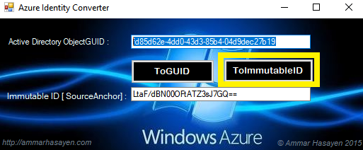

Now run these commands as admin in PowerShell:
install-module msonline
Import-module msonline
$credential=get-credential
Connect-msolservice -credential $credential
set-msoluser -userprincipalname tmerge@atc-hq.com -ImmutableId LtaF/dBN00OFtATZ3sJ7GQ==

Next: move the new duplicate local ad user to the proper OU for the user (ATC Edmond, ATC Remote, etc.)
Next: manually sync Azure AD Connect on our local server

After the synchronization, the user will now be able to log in locally and in Office 365.
The password you created when you created the duplicate account in local AD is the new login password.

